

Unable to meet the needs of a customer

Slow implementation cycles

More efficient solutions

Touristic visits adapted to his takes and needs

The Problems are taken care of a individual personal

Heavy traffic in the complaints and more waiting time

Inefficient decision making processes

take short courses to keep learning

What does the customer say about the service

How does the customer reacts to the service provided? Is he satisfied?!

Shop small and local

An opportunity to solve the real world problems and to see many customer satisfied

Can also implemented with AI which will respond to the customers with some basic solutions.

Little bit tough to implement,as there are many fields in it.

Is your customer more in a private environment?

Mostly , It will not reach many people needs , because assigning individuals for each and every complaint ticket is impossible.

What problem does the customer face in his environment?

Assigning customer tickets to a individual will be a best solution to attain each and every customer's satisfaction

Empathy Map Canvas

Gain insight and understanding on solving customer problems.

1

Build empathy and keep your focus on the user by putting yourself in their shoes.

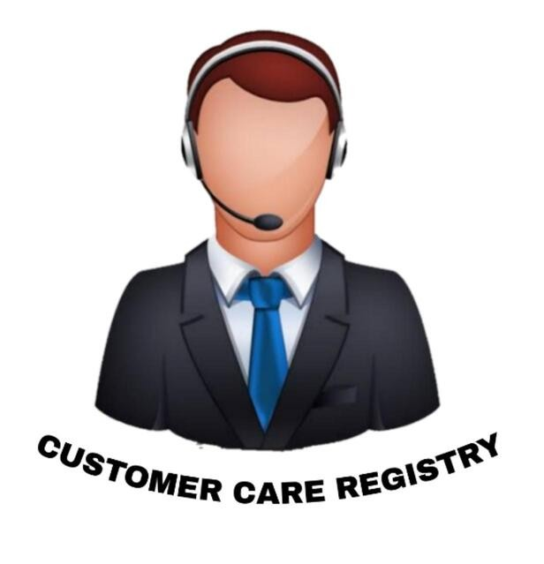

Will be an effective solution to the recent E- Commerce sites and apps where the customers sometimes get troubled by scam products

Customer Care Registry will be useful for many customers , who are not satisfied with their products.

Customer Service in the recent times are not that effective , so it will be an effective solution for the current problems.